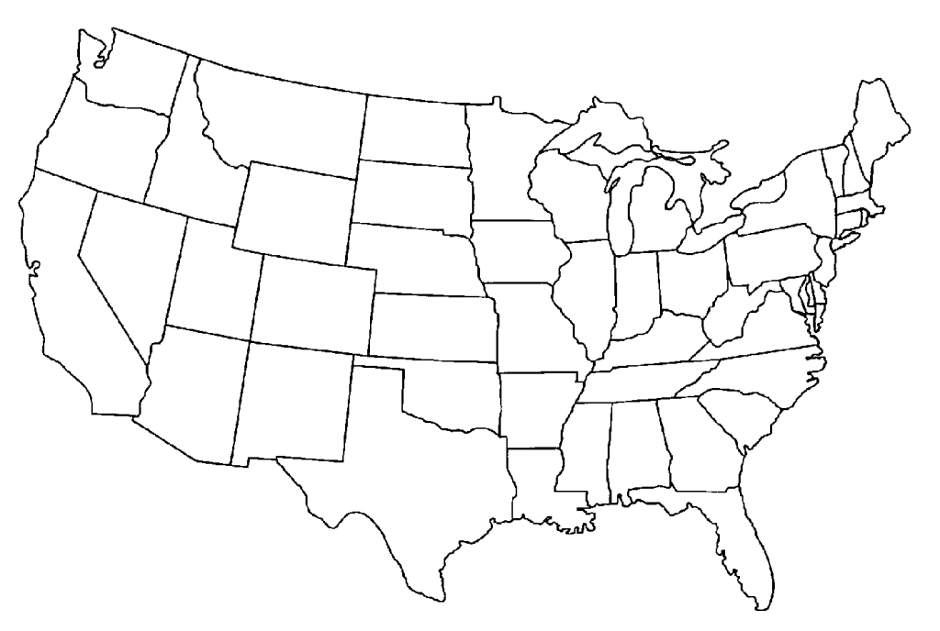United states western Region

Study Guide

11

12



10

9



8



5



7

6

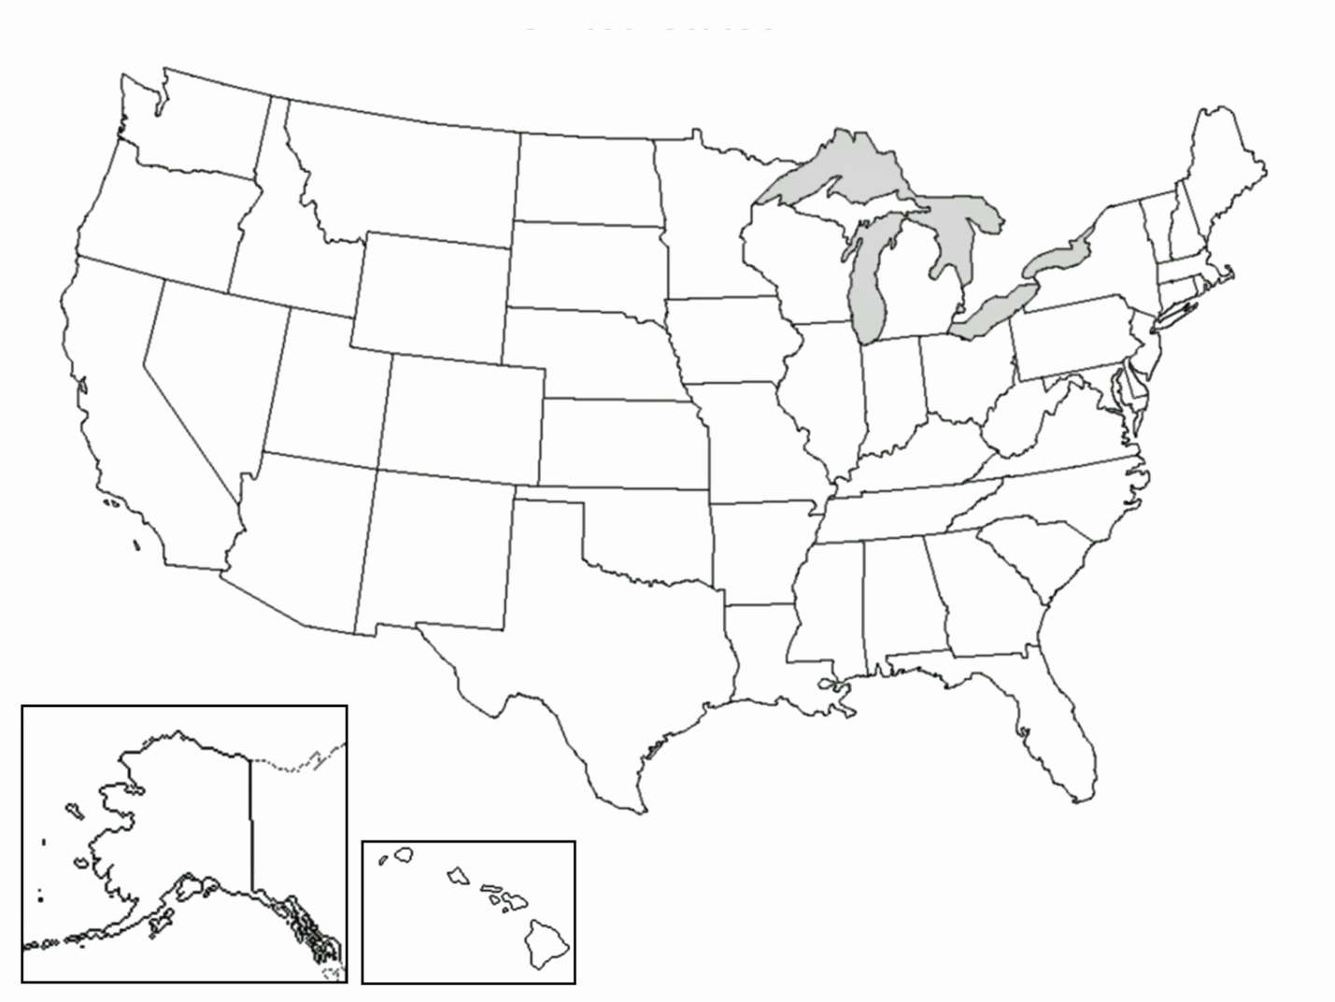

4



3



14

2

1



|  |  |
| --- | --- |
| 1. | 8. |
| 2.  2. | 9. |
| 3 | 10. |
| 4. | 11. |
| 5. | 12. |
| 6. | 13. |
| 7. | 14. |

13

